1.Create a Html file with My Success Story as title.

2.Create a Html file with the paragraph about your studies journey as a body with “My Qualification” as heading 4.

3. Create a html file with pre tag for your college details with     heading 5 as “ My College”.

4. Create a Html file with table having sno, family member, title   and age as table heading.

5. Create a Html file with atleast three rows inserted into the   above table.

6. Create a Html file with unordered [list](http://learning.microcollege.in/mod/assign/view.php?id=19552) of your hobbies. And   make hobbies as heading.

7. Create a Html file with Success Story as Summary and Details   inserted within that Summary.

8. 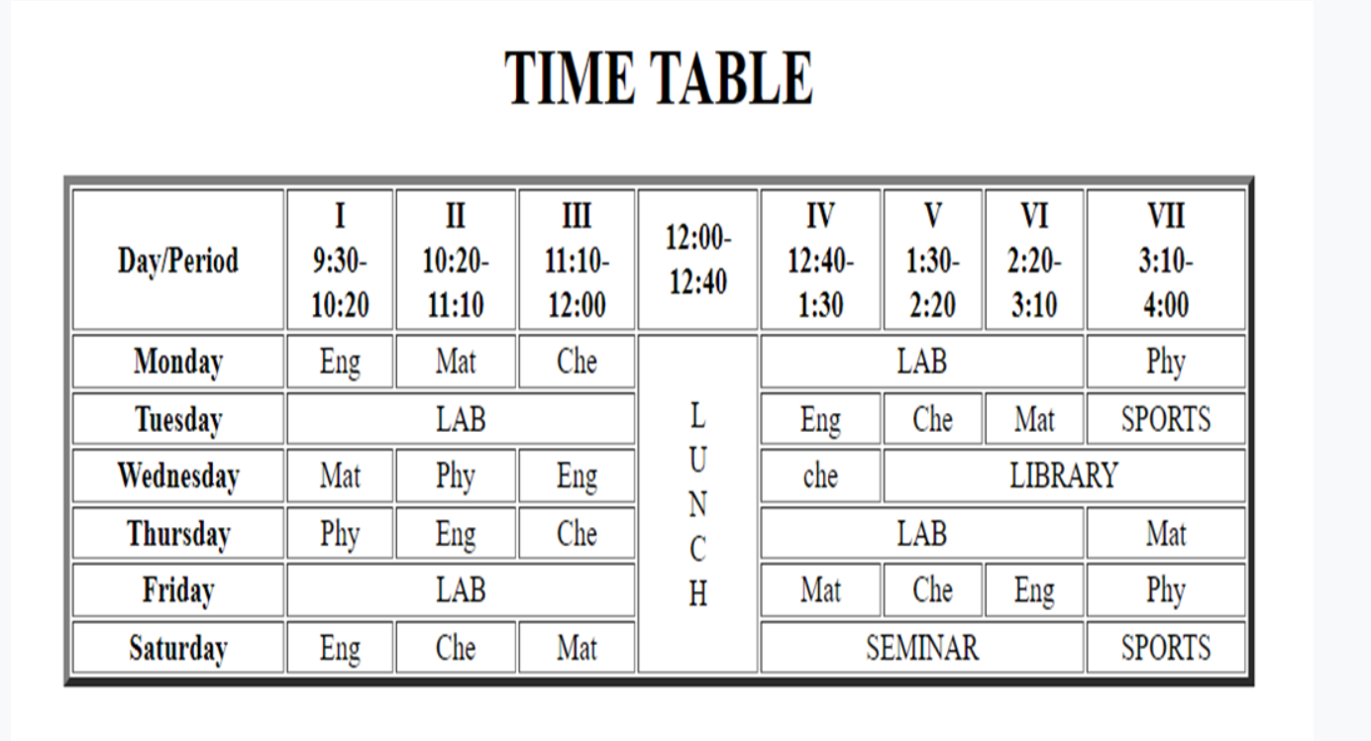

9. 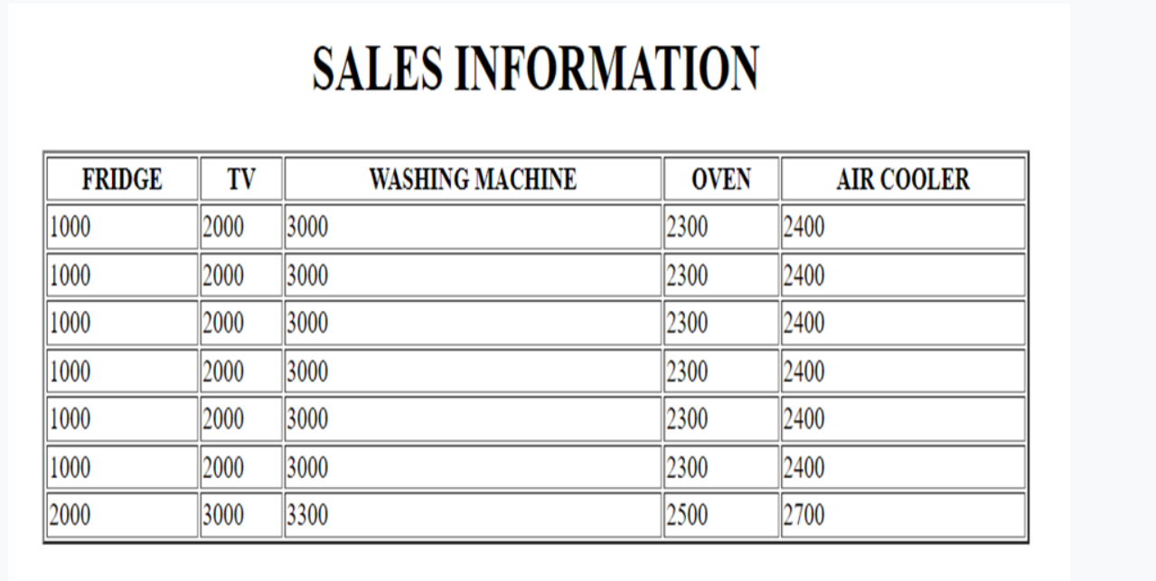

TASK3 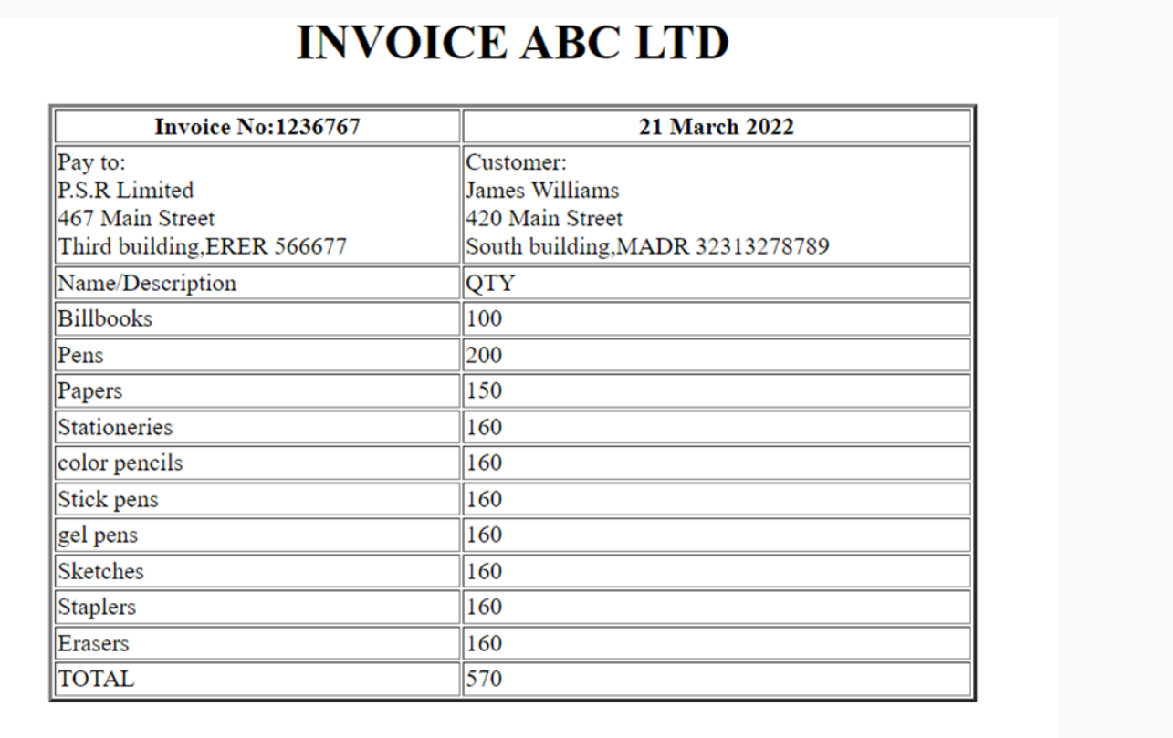

TASK4

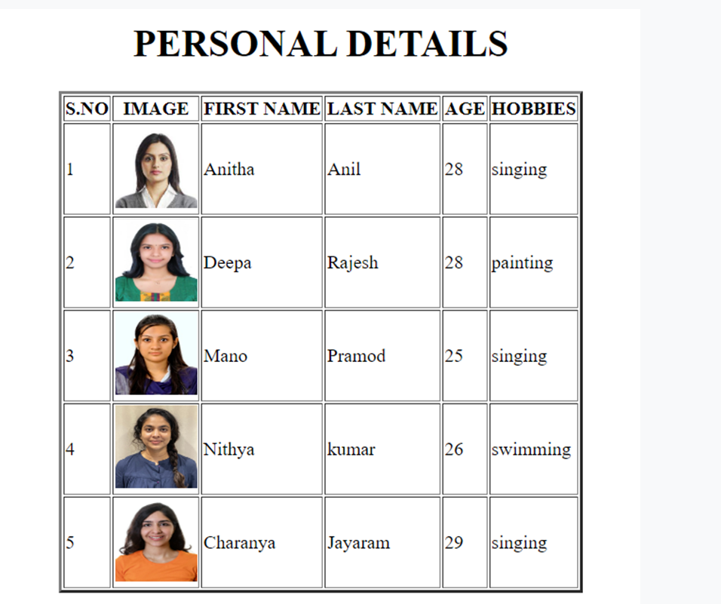

TASK5

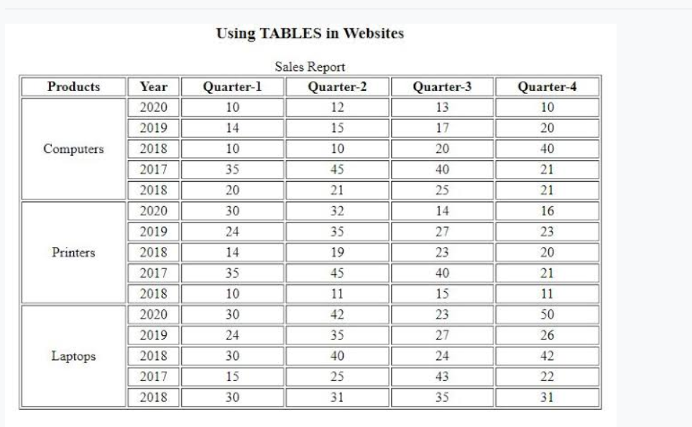

* Use the audio tag to embed the file on your page. Make sure it plays.
* Use attributes on the audio tag to make the file autoplay and loop forever.
* Use the video tag to embed the file on your page. Make sure it plays.
* Make the video 600 pixels wide and remove the controls, using attributes of the tag.